Unlocking the Gates: Study Guide

The Fiftieth Gate develops powerful ideas about the interplay of history and memory in revealing and coming to understand a past ‘situation’*- The Jewish Holocaust.
For you, the focus of deconstructing Baker’s text lies in a balanced examination of how and why he does a) the above, but also evokes b) a discourse about history and memory in representation.
There are key elements of the text that must each be touched upon at least once in an extended response. The following is a breakdown that forces you to focus on important elements that contribute to the text so you can use on them in the exam to answer a question.
Reread each gate prior to completing each section of the study guide. You will be issued 3-4 gates to study as the ‘expert’ on that gate, and present a three to five minute discussion to the class.
*‘Situation’ is the closest diction to encapsulate the Jewish Holocaust, as nothing really can in a word.

Gate III

Here in this carload
i am eve
With abel my son
If you see my other son
Cain son of man
Tell him that i
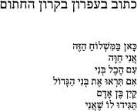

-Written in Pencil in the Sealed Railway-Car (Pagis)
http://www.uscj.org/koach/kocapr03shore.htm
After examining the poem and the above link, make a comment of a few sentences on the purpose of each of the following:
- the fragmented form and construction as a reflection of exploring dying memory and experience
- the paradox of the lack of identity of one of thousands in this experience, against Eve, known mother of humanity
- the biblical allusion referring to creation and death in such a significant moment both in the past (for poet) and present (for Baker): http://en.wikipedia.org/wiki/Adam_and_Eve
- the use of this poem as a motif. The poem is repeated throughout the novel in fragments. Why?
The other element to this gate is the various perspectives of Treblinka as an example of interplay to represent a ‘situation’; Baker, the Israeli students, the survivor who built the model, Pagis… this takes the individual and turns it to the collective. Discuss this in about a page. Use ONE other significant gate that also does this to capitalise on examining this method.

Gate VIII

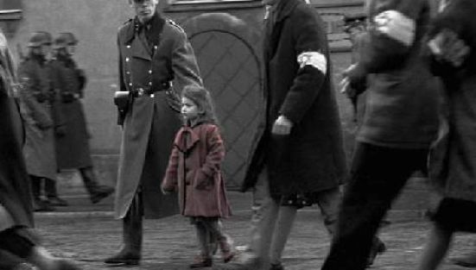

Baker intersperses two versions of Genia’s memory: the first in italics; an interview before visiting her birthplace, and the second; her words when she returns and sees places that stimulate her memory. Both are subjective but are distinctly different.
The gate also connects the past with the present.
Examine the language (syntax, diction, tone including irony, coherence and structure, emotive intensity) of each to conclude how context and perspective shape the differences in representing history and memory. Write about a page.

Gate XXII
Quick Sentence Q & A:
- “It gnawed at me, the feeling that my father’s narrative had surrendered to forgetfulness” (pp. 124)
What is the effect of using the metaphoric diction “gnawed” and “surrendered”?
- “It goes something like this, his life: Wierzbnik, a child. Stop. The war. Stop. No father. Stop. No mother, sisters. Camp. Starachowice. Stop. Auschwitz. Stop. Buchenwald. Stop. Start.” (pp. 125)
What is the desired effect of the sharp syntax?
- Other than forgetfulness and subjectivity, what is symbolic about Baker’s father offering different dates of birth on pp. 126?
This gate is framed by the short preceding gate XXI, and followed by the short gate XXIII. Together these gates set stark contrasts of tone and pace with the retelling of event and actions in gate XXII.
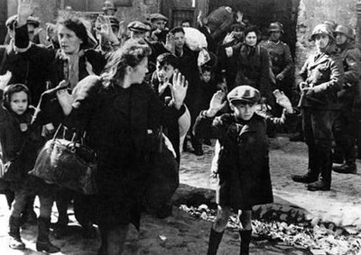
The underlying focus of this gate is the ongoing discrepancy between Baker’s research of his history and his father’s memories: A juxtaposition of facts and history; reader sympathy and objectivity and, first hand account and memory; reader empathy and subjectivity.
Write THREE paragraphs that make explicit the above in three different ways, using different textual references and literary devices as a way of separating information in the paragraphs.
Your thesis for the three paragraphs could be the way gates XXI, XXII, and XXIII use a ‘process’ of history and memory to show how Baker uses the discrepancies to actually engage his reader and construct a holistic representation of Wierzbnik, October 27 1942.

Gate XXIV
The integrity of the writer, and respect to memory that is revealed in this gate is paramount in expressing ideas about tone and purpose. The reliance on history to prove “…events relayed in bits and pieces over the years.” because Baker’s mother’s scars “were invisible” is a showing of the relationship between history and memory, and how either can be reliant on the other.
Baker’s investigation of history is the gate to unlock his mother’s silenced memory.
Prove this statement in TWO paragraphs with a close study of gate XXIV. Include quotes that show memory complimenting history.

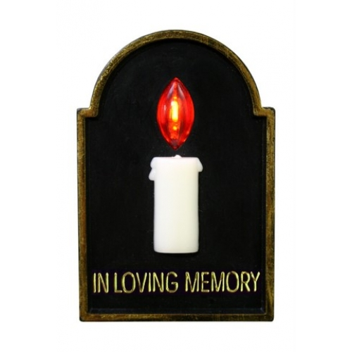
Quick Sentence Q & A:
Why does Baker mention he has been reading his father’s Yizkor book?
Why does Baker utilise rhetorical questions frequently during this gate?
What do we realise, in this gate especially, that is at risk of being lost?

Gate XXVII
While history has been shown to help unlock memory, this gate seems to demonstrate that history can fall short against memory. What is revealed by the following key quotes?
- “I could not answer her. The final moments can never be retrieved by history. Nor by memories: for every life, there are countless other deaths” pp. 156
- “This was the only answer I could afford my mother but I did not give it to her.” Pp. 159
Find ONE other quote that demonstrates how memory can compliment history in representation.
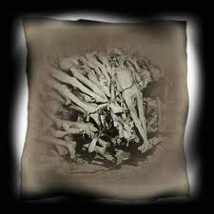
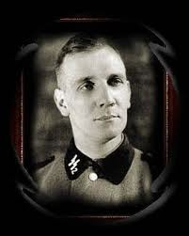

Majority of this chapter is the memoirs of Officer Kurt Gerstein. Discuss the differences in writing style (language) to demonstrate a different memory (content) of the incidents described by Baker’s parents. Write about half a page.

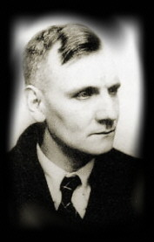

Gate XXVIII
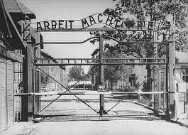
This gate may prove that while history can be examined and revisited, it is memory that attaches humanity to history.
Do you agree?
Write about a page on this, remembering to find a balance of how and why in your argument.
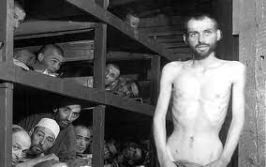
“Mr Baker. You were here. I found your registration in the administration office. You were number A-18751.” Pp. 166
Touch on the significance of ‘place’ and validation in your discussion of the above.

Gate XXX
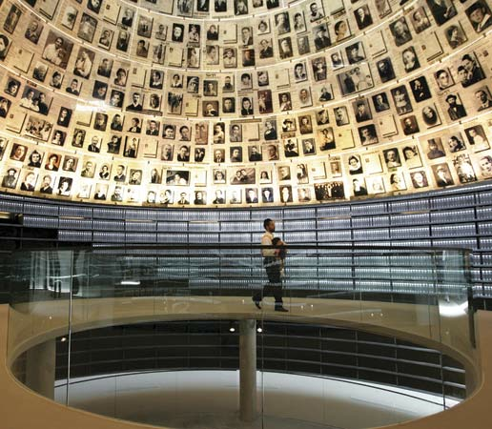

http://www.jewishvirtuallibrary.org/jsource/Holocaust/Vashem.html
Click on the link and read the page.
Make a list for each of the following:
Baker emphasises the Yad Vashem as a place of importance. What does it offer to him, his family, his parents and Jews?
Find examples of imagery he uses (metaphor and simile) to establish a changing attitude toward the library throughout this gate.
What overall assumptions can be made about history and memory after reading this gate? Write about half a page.

Gate XXXII
The writer, Primo Levi, tells of a recurrent nightmare he had in the concentration camp, one that forecast the outside world’s reaction to the Holocaust: that he would survive and return to life, where he would try to tell others where he had been, what had happened to him, what he had witnessed. And he would be met with disbelief. It is the premonition of disbelief that was Levi’s nightmare.
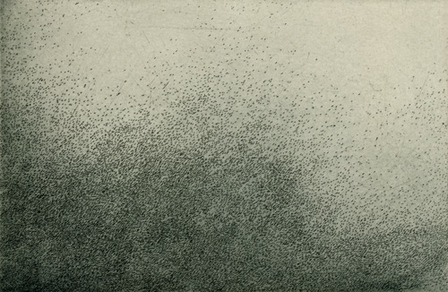
Furthermore, the SS also forecast this incredulity, mocking the prisoners:
“However the war may end, we have won the war against you; none of you will be left to bear witness, but even if some survive, the world would not believe him… And even if some proof should remain… people will say that the events you describe are to monstrous to be believed…”
When history and memory fail us faith or belief is all we have. Write a paragraph on each of the following:
1. What is Baker afraid of in this part of his work? Consider the fearful consequence of disbelief.
2. What does this suggest about attitudes towards individual experience and memory against historical documentation?
3. There is a kind of irony in the juxtaposition of Baker’s “I don’t believe it… Prove it.”, and Genia’s recitation of The Lord’s Prayer, “My mother, Jesus little helper.” What does it allow the reader to contemplate?
4. “What, all these years you thought because I wasn’t in Auschwitz like your father that I didn’t suffer? Because I don’t have a number means I didn’t survive?”
This journey through history and memory is developing new maturity as the text progresses. Explain what new maturing or process of evolution is occurring for Baker. Cite other gates in a one-page response.

Gate XXXIII
Find evidence for each of the following:
- A contemplation of Baker’s own, and his family’s, existence is born out of him referring to the nature of survival and the Holocaust.
- Kogut is a marker for connecting the recorded history and fragmented memory into a more coherent story representing the situation of the Holocaust for Yossl, and for the men in his family that were unable to carry the kin further into history.
- Kogut substantiates Yossl’s memory, whereas there is no survivor to verify Genia. This is an ongoing motivator for Baker.
- History and memory intersect in gate XXXIII.

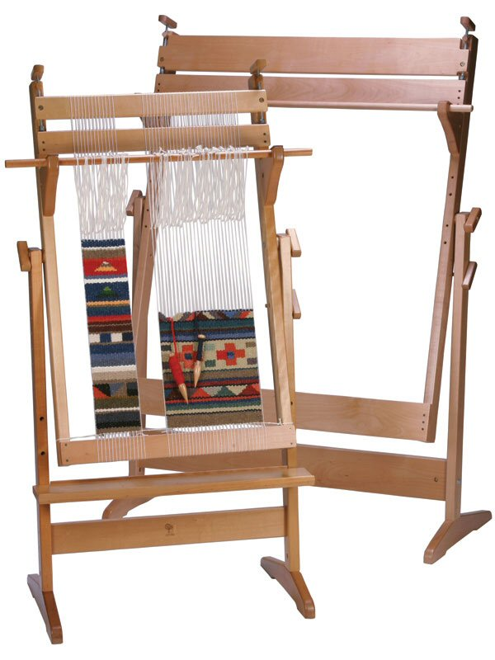

Gate XXXIV

“This book will be for dor dorot, for generations to come... Please, I beg you, be careful what you say. It’s forever.”

- In one paragraph, why does Baker include this comment in the text?
- In two paragraphs, what kind of concerns about censorship are raised because of the content of this gate?
- Does history have a responsibility to retain memories, even if they wish to be forgotten or omitted? Justify your one-page answer using Baker’s text, and this gate, as the exemplar.

Food For Thought…
The images below are a same history represented by two different groups: The Americans and the Vietnamese. History, like memory, is subject to interpretation shaped by context and values.

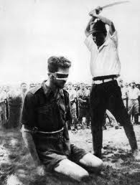
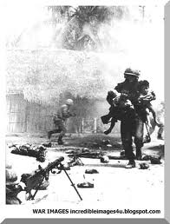
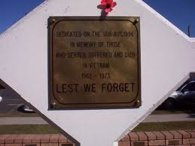
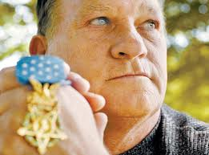
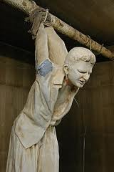
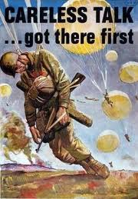
…including the evacuation of Vietnamese orphans.

During April 1975 a RAAF detachment of 7-8 Hercules transports flew humanitarian missions to aid civilian refugees…
And cost Australia 521 lives (over 3000 were wounded).

The Vietnam War cost the United States 58 000 lives.

Australians and Americans fought with the South Vietnamese when they couldn’t fight for themselves.

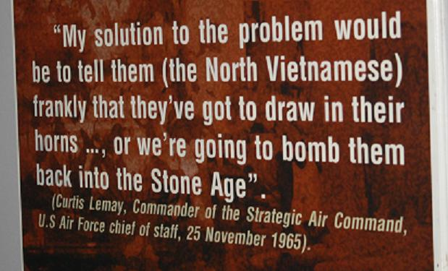
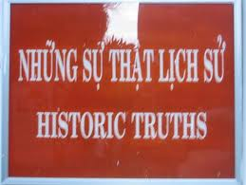
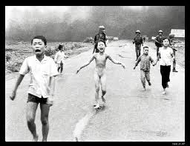
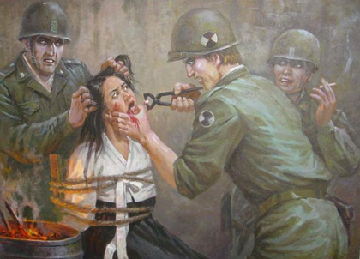
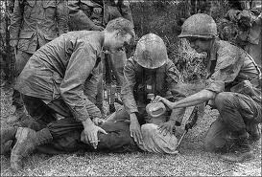
Gate XXXVI
(among them were 2 million civilians)

2 million were injured, 300 000 were missing…

…3 million Vietnamese were killed

During the Vietnam War…

The juxtaposition of the histories:

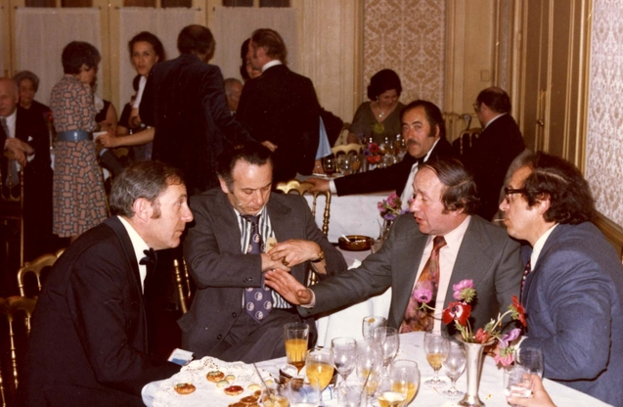

So much history (evidence) of persons, place, artefacts, documentation exists that proves Yossl as a “survivor”. The anaphora in this gate- “my father” is an affirmation that can only exist with observing photos, visiting places, examining records. Therefore it is Baker, the son and researcher, who provides the space and time for “different time-frames (to) collide in front of an invisible row of barracks.” In about half a page, what does this bring to the text for the reader in terms of our study?

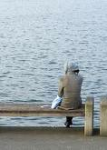

Genia is a “lone survivor”. The mood which Baker creates using the ambigious diction concerning his mother, “time lost”, “time that never was”, black hole”, “absent years”, illuminates the void in which Genia’s past exists. It demonstrates Baker’s helplessness and inner conflict of not being able to show his mother’s history with the same concreteness as his father’s. Comment, in about half a page, on Baker’s inclusion of “My mother sat by my father’s side and wept as she sang the same melody. She is more consumed by the past; there are no girls to grow old with.”

It is Genia’s memory that must be trusted. The “cruelty” Baker writes of is not just the contextual horror, it is the lack of acknowledgement and the questioning of a woman’s loss, fight and survival. There cannot be a collision (connection) of time between mother and son, as there was in April 1995 in Buchenwald. How does he compensate for this in this gate and one other gate? Write about half a page.

Read page 232. Baker’s parents fought so hard to live. What does the intention of the creation of this text foreshadow? Why does Baker feel shame? Write a page.
Gate XL

Using gate XL, prove (or disprove) the statements below in about a page each. You should draw on additional gates to support ideas. Try to include the effect of each:

1. In piecing together his parents’ lives using history and memory, Baker has also created a narrative that spans generations of his family.

2. At times, Baker’s recounts touch us all and remind us of the importance of our own memories, and how we can contribute to history.

3. Baker clearly demonstrates the interconnect-ability between past, present and future.

4. Writing about history and memory is one thing, but you must utilise the features of prose to develop emotion and create engaging meaning for the responder.

5. The text is coming together as an interplay of Baker’s personal experience, his parents’ memories, and official documentation. In the surrounding gates, and in this one, Baker seems to write in a more personal and intimate manner of himself.

Gate XLII

Reread page 15.

Gate XLII is a recreation inspired by a poem. This gate is highly emotive prose because of the nature of what has been written in the previous XLI gates, and because of the empathy it generates. It could be deemed ‘creative non fiction’. This is because the narrative is underpinned with historic facts, deep research of the Jewish Holocaust, extensive recounts of memories, and cross referencing of all of this. Sometimes, neither history nor memory is enough.

Quick Q & A:

- Prove that this gate is creative writing. What literary techniques does Baker use?
- What new meaning is given to the poem, and the ‘situation’ of the Holocaust, from this gate?
- How does this prose contribute to Baker’s perception and depiction of his parents’ history and memory?
- Why does Baker exercise this prose here, and at all?

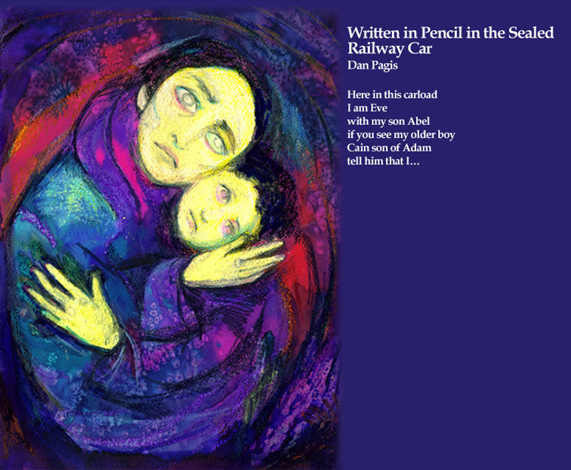
Gate XLIV

“Around the corner from my mother’s lone stone stands my father. He shares his rock with his friends…”

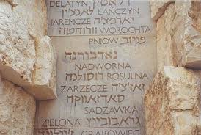

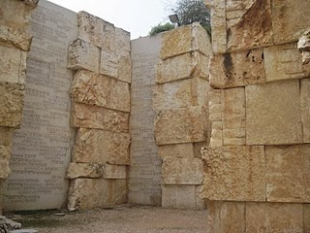

Is history only worth remembering if others share them same history? Write about half a page, using evidence from the text, to support your answer.
http://www.harpercollins.com.au/author/authorExtra.aspx?authorID=50000641&displayType=interview
Click on and read the above link. Write half a page, using evidence from the interview, to support a possible answer that Baker might give.
Write half a page, using evidence from the text, to support a possible answer that Yossl might give.
Write half a page, using evidence from the text, to support a possible answer that Genia might give.

Gate XLV
“There is nothing that connects their lives in Poland except that they were both victims of the same hatred.”
1. What has Baker’s novel done for his parents? Make a list of possible outcomes.
Reread pages 290 – 291. Baker has been scrupulous in his “fact finding mission” throughout the research and writing process.
2. In THREE separate ways, comment on how pastiche has played a significant role in reflecting this.
3. Out of a quest to confirm his father’s memories, Baker’s conversation with Avraham opens a gate to his mother’s memories: “”It wasn’t a village,’ I protest on my mother’s behalf. ‘It was larger than a kfar; it was a shtetl, a beautiful one-“
Look back through several gates. In about half a page, what have become of Genia’a memories?
“Every prayer, every prayer opens another gate. Six million prayers. Imagine how many gates are open to you.”
4. Discuss how the idea of memory and the gates intersect here in half a page.
“Towards the fiftieth gate where light hovers inside the darkness. Inside the broken heart.”
5. Discuss the meaning and effect of this last sentence in half a page.

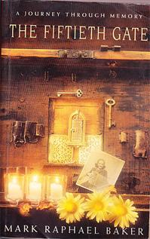
Gate XLVI

Make brief comments on the layout of this gate:

Is it effective?
Why does he segment it?
Why does he use sub-headings?
What does this gate reveal about Baker’s parents?
What does this gate reveal about Baker?

‘I have set before you life and death, the blessing and the curse: therefore choose life’ (Deuteronomy, 30:19).

Once again, the text brings us back to belief to fill a void between history and memory. What does this text say about the human condition? Write about a page.

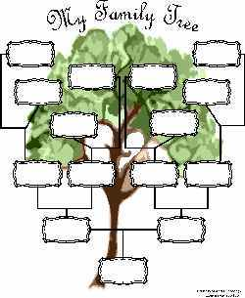

Carefully reread the text under the sub-heading ‘Relatives (‘Gravity Score’ for Children)’. Baker and his parents have not only opened gates to history, he has opened gates to the future. In TWO pages, discuss the value of understanding and responsibility when recording a family history AND a ‘situational’ history.

Gate XLVII

Reread page 304. It is clear that Baker has achieved his goal of verifying and connecting his parents’ individual experiences of the Jewish Holocaust and their lives that followed. Baker reveal’s something about himself at the top of this page. After conveying the importance of history throughout the text, what, how and why does he include the comment about burning his personal history at this moment?

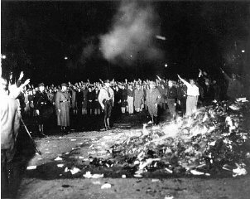

How does Baker convey the elation his mother feels when he finally finds evidence that confirms her memories, that confirms she was a little girl living the Jewish Holocaust?

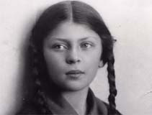
Gate XLIX

Read the dictionary.com definitions below:
cel·e·brate  1.  to observe (a day) or commemorate (an event) with ceremonies or festivities: to celebrate Christmas; to celebrate the success of a new play.  2.  to make known publicly; proclaim: The newspaper celebrated the end of the war in red headlines.  3.  to praise widely or to present to widespread and favorable public notice, as through newspapers or novels: a novel celebrating the joys of marriage; the countryside celebrated in the novels of Hardy.  4.  to perform with appropriate rites and ceremonies; solemnize: to celebrate a marriage.  Origin:  1425–75; late Middle English < Latin celebrātus past participle of celebrāre to solemnize, celebrate, honor, equivalent to celebr- (stem of celeber ) often repeated, famous + -ātus -ate1 | com·mem·o·rate  1.  to serve as a memorial or reminder of: The monument commemorates the signing of the declaration of independence.  2.  to honor the memory of by some observance: to commemorate the dead by a moment of silence; to commemorate Bastille Day.  3.  to make honorable mention of.  Origin:  1590–1600; < Latin commemorātus (past participle of commemorāre ) to recall, put on record, equivalent to com- com- + memor mindful + -ātus -ate1

“Seven Jews”… “from four corners of the world gathered in Isreal half a century later to celebrate their survival.
‘Not celebrate’, my mother corrects me, ‘commemorate.’
They commemorate by celebrating…”

What is the difference, and how does this extract relate to the relationship between history and memory?

“She must keep dancing, perhaps driven by the painful awareness that she has no table of her own to join, except as a visitor intruding on other people’s towns.” (pp. 311)

Read the section at the end of the book titled Notes and Sources. What has been Baker’s overall intention for this researching and writing process? Did Baker achieve this?

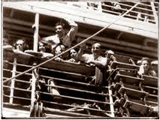

Read the two paragraphs at the top of page 312. How do Baker’s parents, and the hundreds of survivors of the Jewish Holocaust influence Australia’s collective history and memory? Do a little research to inform you half page to a page response.

Write a ONE page response, incorporating gate L.

“Freedom is not a happy ending. It is a flame that dances in remembrance, inside the blackness.” (pp. 314)

Discuss how this quote could be a metaphor for the interplay between history and memory.

http://www.youtube.com/watch?v=gRmG-aRBsPI

Click on the link above. What have you learned about the interplay of history and memory, from reading Baker’s The Fiftieth Gate?

Be sure to have read this text cover to cover. Much can be understood by the additional notes.

